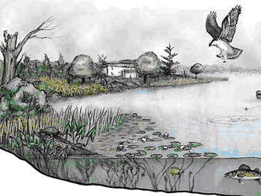 | Ecosystems Inquiry Lab Write-up

Use the Science text book and your notes, observations & research to complete this assignment.

The write up will include:

Detailed qualitative observations
Measured data, charts, tables and graphs
Drawings, diagrams and pictures
Complete answers to questions with details and elaboration

Section 1: PURPOSE
- Problem, hypothesis, question or phenomenon
- A description of what the purpose of doing the lab is. What is being tested? What does the lab try and show, prove or help understand?

Section 2: MATERIALS
- A detailed list of everything that is needed to carry out the inquiry so that another scientist can reproduce the experiment in exactly the same way.

Section 3: PROCEDURE

A detailed step by step description of how you constructed the ecosystem.

  - How did you build your ecosystem?
  - What did you include? Why?
  - Why were these elements necessary to include in the ecosystem?
  - Which organisms were producers, consumers, detritivores, decomposers? (make a chart)
  - How did you set up to get ready to observe your ecosystem? (data sheet)
  - What do you need to do once the set-up is complete?

**Diagrams and Pictures are an important part of sections 2 and 3 **
- They should have captions, must be done carefully and must be labeled accurately to further clarify how the experiment was set up and carried out

Section 4: DATA AND OBSERVATION

***This section includes 3 charts and 3 graphs***

- The charts have 3-4 specific examples
- The graph must show change over time:
  - Graph examples:
    - Water and plant growth
    - Organism weight
    - Snail weight

Chart & Graph 1: Roles and Relationships

- Identify the roles (niches), relationships and interactions of at least 4 organisms in the ecosystem.

Example:

Roles and Relationships
Organism | Niche | Relationship to Abiotic elements | Data
1. Plant | To produce oxygen and provide shelter for organisms | - Soil provides stability to plant  -Uses the sun and water to make its own food | -we added soil and water and made sure the plant was by the window
2.
3.
4.
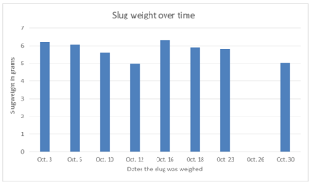
Graph:

Graph Analysis and Explanation:

Detailed explanation/interpretation of what the graph shows goes here

Chart & Graph 2: Changes and Contributing Factors

- Describe 4 or more changes (2 you made and 2 that happened on their own) you observed in the ecosystem.
- To the best of your ability, explain why they happened and whether it beneficial or detrimental to the overall health of the

Example.
Changes and Contributing Factors
Additions/ removals/ Change / Observation | Reason | Impact of change
- On November 3rd we planted more grass | Most of the grass had dies and we felt the organism needed more producers for oxygen and shelter | -the grass started to grow  - the snails spent more time in the grass area
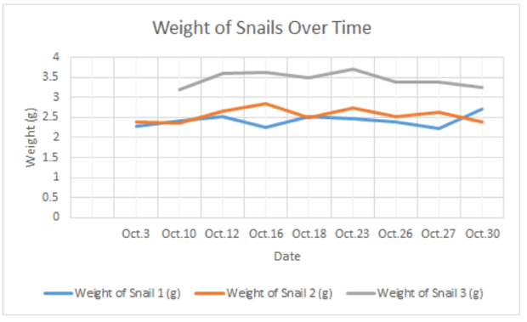
Graph:

Graph Analysis and Explanation:

Chart & Graph 3: Evidence of Energy Transfer

- Describe how energy was transferred through your ecosystem. (include at least 3 several specific examples with explanations and supporting data)

Example.
Energy Transfer
Evidence (data) | Explanation
1.
2.
3.
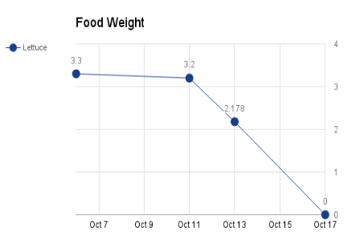
Graph:

Graph Analysis and Explanation:

(Bonus) Chart 4: Carbon and Water Cycle

- Describe the water and carbon cycles that occurred in your group’s ecosystem. (include several specific examples with supporting data)
- Make a chart and graph any way you chose

Section 5: CONCLUSIONS

Answer the following questions to describe show your final observations and the conclusions you have reached after analyzing the contents of your ecosystem.

  - What makes a good ecosystem?

  - Would you consider your ecosystem a good ecosystem for the organisms in it? Did it meet the needs of all organisms? Explain in detail using data collected to support you opinion.

  - How did you affect the ecosystem? Were your actions helpful or hurtful to the ecosystem overall? Explain.

  - Do you think your ecosystem was better for your organisms or worse for them than their natural environment? Include at least 3 examples with explanations.

Section 6: SOURCES OF ERROR & IMPROVEMENT

Describe at least 5 sources of error & improvement - this is an analysis of what may have caused the results to be different or inaccurate

- Make a chart to organize you thinking
- How could the experiment be changed or modified in order to make it better? Include 3 or more hypothesis statements with an explanation (Use hypothesis statements: If….then...)

Sources of Error

Source of Error | Explanation
1.
2.
3.
4.
5.
Improvements

Hypothesis Statement | Explanation

Questions:

Use examples to help you answer and explain the following questions. Answer in complete detailed paragraphs.

- Use an organism in your ecosystems to show your understanding of natural selection and evolution. Consider the following questions to help you:
  - How do adaptations influence natural selection?
  - Why do some animals have better chance of survival?
  - Why do animals change over missions of years?

- How does natural selection and the fact that there are so many different ecosystems in the world help explain the diversity of life on earth?
- Do you think ecosystems are fragile, stable, or adaptable? Why?
- What can happen when a new population is introduced into an ecosystem?
- Why can organisms in an ecosystem share the same habitat but not the same niche?
- How can humans effect ecosystems? Provide at least two positive effects and two negative effects and explain.

Extras

Do some research to formulate your own opinion, then answer the following:
- Why should we be concerned with biodiversity vs monoculture?
- Why is it important to preserve natural ecosystems around the world?
- What are the competing forces that are endangering tropical rain forests?

