Learning Intentions – Measurement
BIG Idea: The constant ratio between the circumference and diameter of circles can be used to describe, measure and compare spatial relationships.
TRAFFIC LIGHT
Green – Fully Understand
Yellow – Mostly Understand
Orange – Kind of Understand
Red – Don’t understand yet

- I can explain the terms radius, diameter, area, volume and circumference
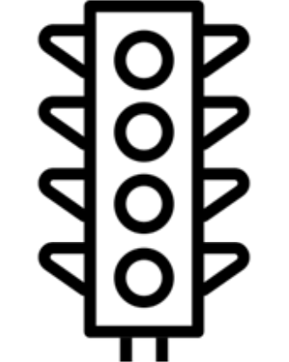
- Radius -
- Diameter -
- Area -
- Volume -
- Circumference -

- I can calculate the circumference of a circle
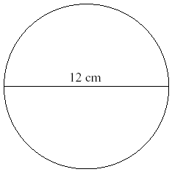

- I can find the area of a circle given radius or diameter

- I can determine the volume of cylinders and rectangular prisms
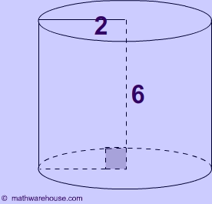
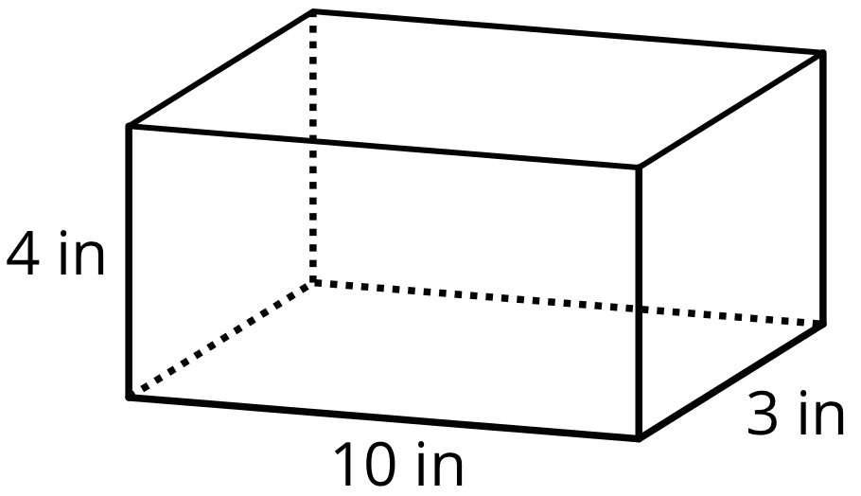

- I can solve problems involving area, circumference, and volume of circles, rectangular prisms and cylinders

If I built a pool that was 10m long by 6m wide and was 6m in depth what volume of water would the pool hold when full?

If I had a room that was 10m by 10m what is the circumference of the largest circle that could fit in that room?

